Computer network Practical
Set-1

Step 1:adding 3 PCS
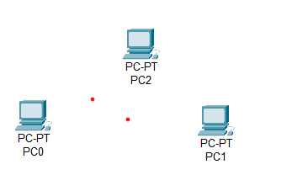

Step 2: add the switch
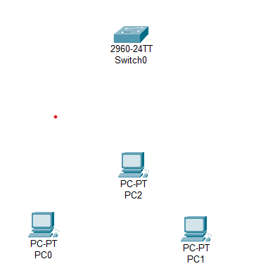

Step 3: connection between pcs and switch
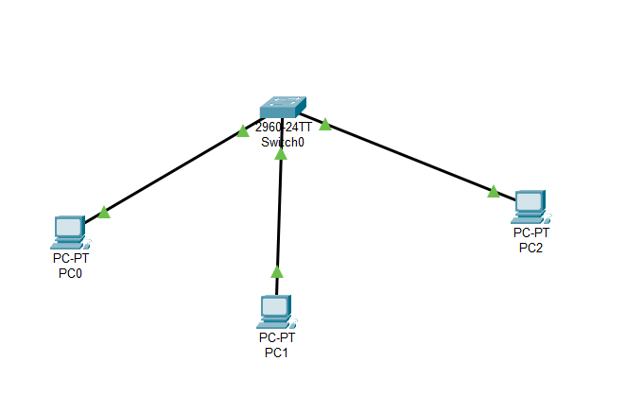

Step:4 PC-PT PC0 doing IPv4 configuration
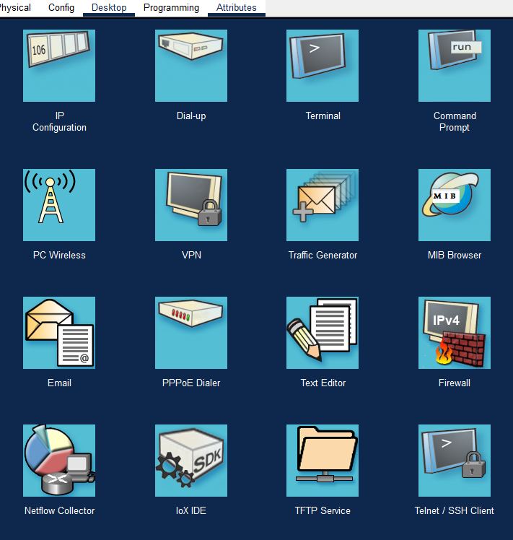

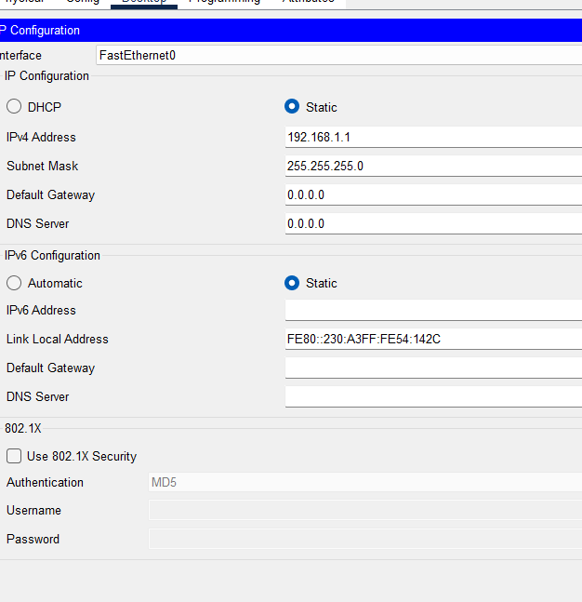

Step 5 – now doing the same with other pc also PC-PT PC2, PC-PT PC2.

Step-6 PC0 desktop and command prompt type ping 192.164.1.2

